

REFLEX & TRANSPARENT LEVEL GAUGE
(SERIES LG33)

Levsen Series LG33 Reflex & Transparent Level Gauge are designed specially to meet most critical requirements of petrochemical, Fertilizer, Pharmaceutical & Chemical Industries Involving inflammable toxic, High Pressure, High temperature liquids. Inner surface of glass has reflecting Prisms. Liquid Levels shows black in contrast to mirror like surface above.

Description
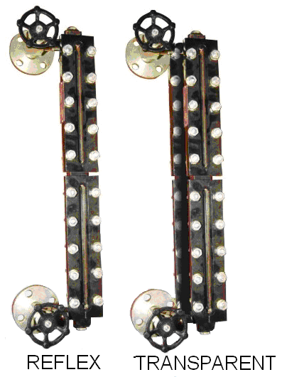
It is mounted parallel, along the side of tank. As the process level fluctuates, the level in the transparent glass tube changes accordingly and gives local liquid indication.

Reflex level Gauge:
Levsen Reflex level Gauge is designed for measurement of liquid level in vessels under high pressure & temperature conditions. It is a flat glass gauge, which has precision Moulded prismatic grooves cut on its inner side coming in contact with the medium. Light striking the glass covered by liquid is refracted (absorbed) into the liquid making this portion appear black, whereas light covering the vapor space is reflected back towards the viewers, making it appear silvery-white. Thus, a sharp clear line marks the liquid, eliminating all possibilities of errors in reading.

Transparent Level Gauge:
Levsen Transparent Level Gauge is designed for measurement of liquid level in tanks under high pressure and temperature conditions. It consists of double flat glass mounted opposite to each other on a chamber. The glasses are held together by studs through cover plates. It is used for interface services or when the process is dirty or viscous.

Specification

M.O.C | : | MS /SS304 / SS 316/ PP
Cover plate | : | C.S/M.S/S.S.
Glass | : | Borosilicate
Bolts, Nuts | : | MS / SS
Process Connections | : | Flanged, Screwed
Packing |  | PTFE
Bolts & Nuts |  | MS / SS
Pressure | : | 100 Kg/Cm² (Max)
Temperature | : | 250 ° C (Max)
Vent & Drain | : | MS /SS304 / SS 316

Application
Boiler , Chemical / Petro-Chemical, Fertilizer, Power generation, Pharmaceutical, Automobile, Cooling / Lubricating / Filtration systems, Liquid sewerage tanks, Chemical dosing system, Chemical reactors etc.

 | 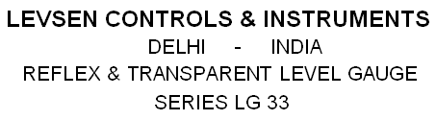
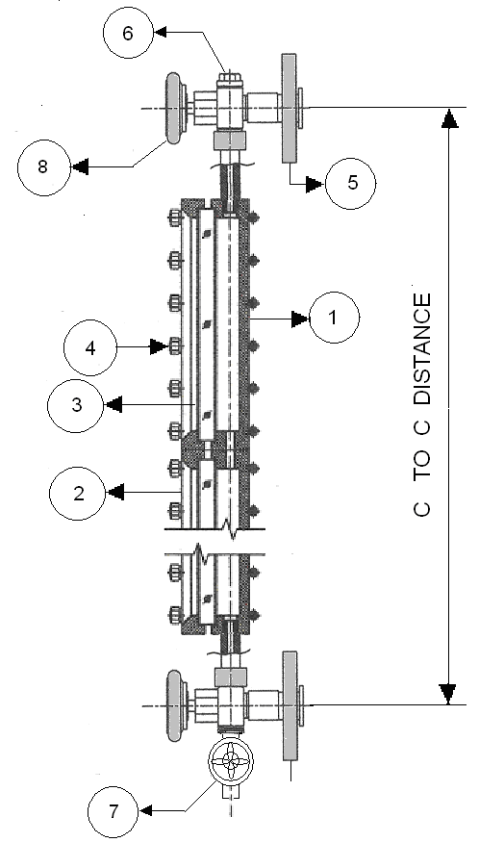 |  | 1.GAUGE CHAMBER  2. COVER PLATE  3. GLASS TUBE  4. U BOLT  5. FLANGE  6. VENT PLUG  7. DRAIN VALVE  8. ISOLATION VALVE | 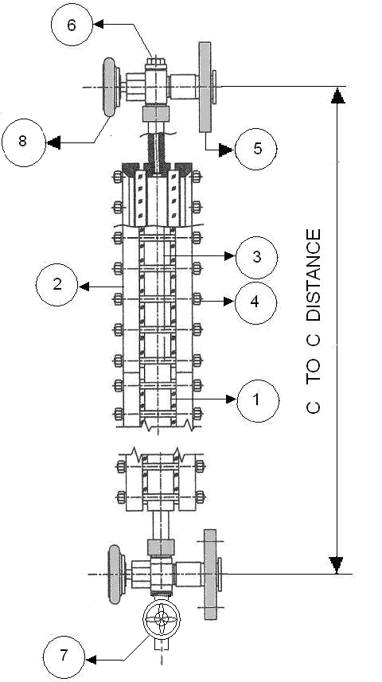
REFLEX LEVEL GAUGE  Features |  |  | TRANSPARENT LEVEL GAUGE
- Designed for liquid level indication in vessels under high pressure & Temperature conditions.
- Suitable for side mounting on Tank/ Pressure Vessel
- Tempered borosilicate glass, resistant to chemicals, thermal & mechanical shocks.
- Flanged connection drilled to ASA 150# or as per customer's requirement.
- Large chamber construction available for boiling, foaming, flashing or surging liquids.
- Isolating valves, safety ball check, scale, illuminator, frost free, heating/cooling arrangement are optional.
- Optional arrangement for frost free, Isolating valves, safety ball check, scale.
- IBR Certification (if required).

